Setting up an RTL with Pothos Flow(Windows)

Device: Nooelec NESDR RTL-SDR - <https://www.nooelec.com/store/nesdr-smart.html>

Step 1: Install Driver -<https://www.nooelec.com/store/downloads/dl/file/id/56/product/0/nesdr_driver_installer_for_windows.exe>

1. Plug your NESDR into an available USB port
2. Open the 'NESDR Driver Installer', Zadig
3. Select 'List All Devices' from the 'Options' menu in Zadig

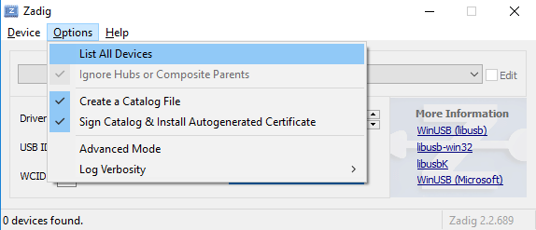

1. From the main dropdown, select the NESDR

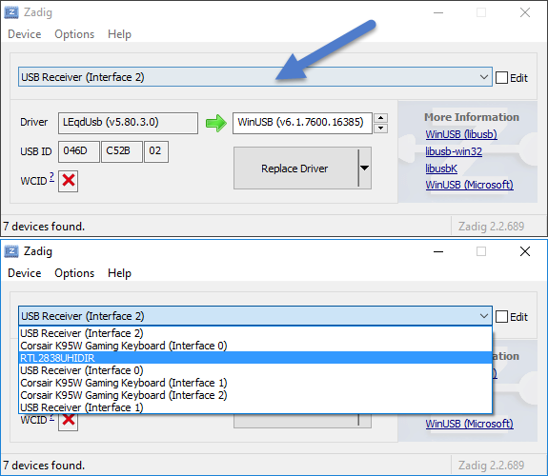

1. Confirm the selected device has a USB ID of '0BDA 2838' 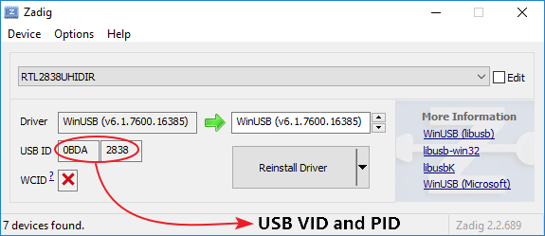
2. Press the big button to install drivers--button will either say 'Install Driver' or 'Replace Driver', depending on your Windows environment and settings. Either is fine.

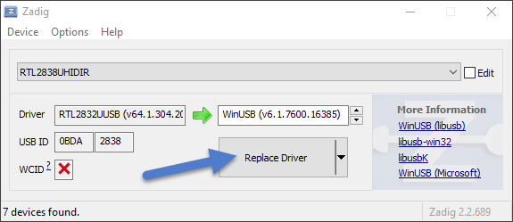

Step 2: Install CubicSDR - <https://www.nooelec.com/store/downloads/dl/file/id/58/product/0/cubicsdr_v0_2_2_win64.exe>

Step 3: Download and Install PosthosSDR

<http://downloads.myriadrf.org/builds/PothosSDR/?C=M;O=D>

Add PothosSDR to system PATH:

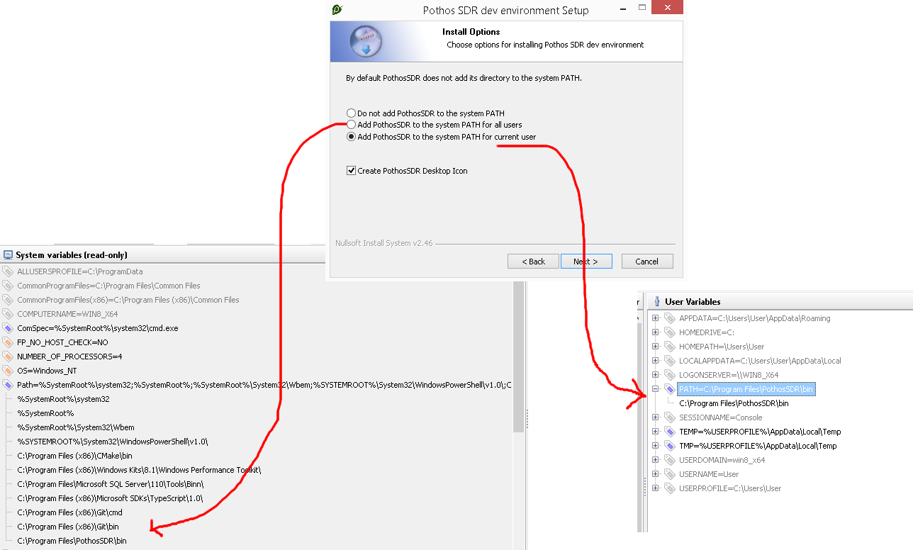

Step 4: Use the command prompt to cd into the PothosSDR bin:

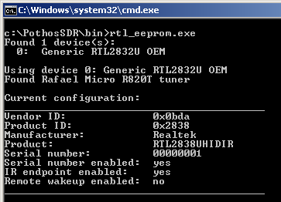

* Run the command “rtl_eeprom.exe”
* Run the command “rtl_eeprom.exe –-find” to ensure device detection:

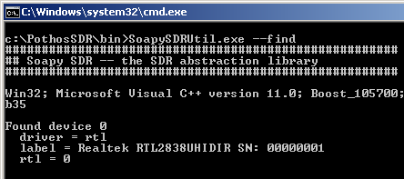

* Instantiate the device with the command: SoapySDRUtil.exe –make=”driver=rtl”

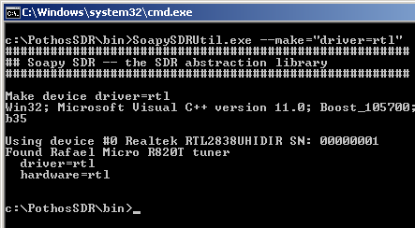

Step 5: Launch Pothos Flow

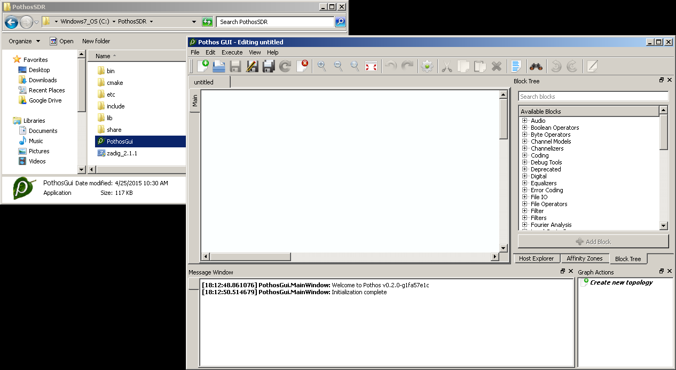

* To visualize spectrum, we will the SDR source block for collecting samples, and the Spectrogram plotter for visualizing the sample stream. Locate these blocks in the block tree using the search feature, drag and drop them into the editor, and connect the source to the plotter.

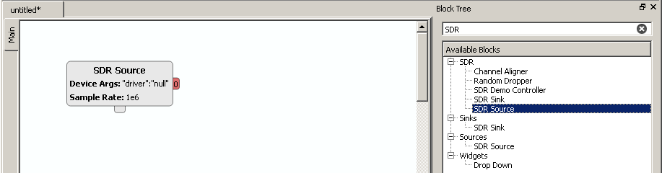

Step 6: [Configuring properties](https://github.com/pothosware/PothosSDR/wiki/Tutorial#id9)

* Before continuing, the SDR source block must be configured. Double click on the source block, and enter the desired device arguments, sample rate, gain, and tune frequency. Device arguments are key/value pairs used to identify a specific device. If this is the only SDR device on the system, then empty brackets "{}" will suffice. Read more about the block properties on the [SDR blocks tutorial](https://github.com/pothosware/PothosSoapy/wiki/Tutorial).

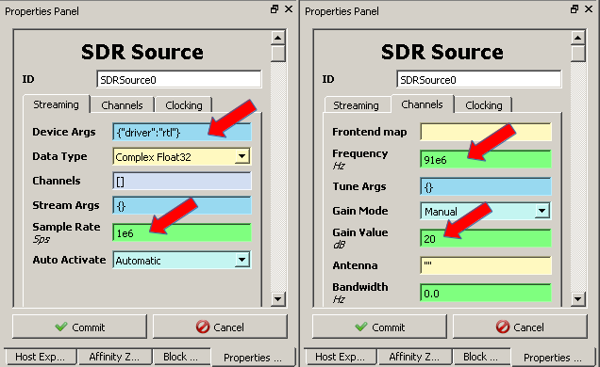

Step 7 :[Activate the design](https://github.com/pothosware/PothosSDR/wiki/Tutorial#id10)

* After instantiating, configuring, and connecting both blocks, right click on the editor and select "Insert graph widgets" to insert the plotter. Then click "Activate topology" in the toolbar or menu to visualize the spectrum.

